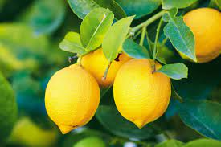
Mrs. Williams
3rd Grade Schedule
Time | Activity | Time | Activity | Min
 | MON,WED/TUES |  | THURS-FRI
8:20-8:25 | Announcements | 8:20-8:25 | Announcements | 5
8:25-8:45 | Tiger Talk | 8:25-8:45 | Tiger Talk | 20
8:45-10:05  (Fowler) | ELA/Reading Instruction  Growing Readers | 8:45-10:05 | ELA/Reading Instruction  Growing Readers | 80
10:05-10:35 | Reading Intervention | 10:05-10:35 | Reading Intervention | 30
10:35-11:20 | Specials-Music (Fowler) | 10:35-11:20 | Specials-PE (Fowler) | 45
11:20-11:50 | ELA/Writing | 11:20-11:50 | ELA/Writing | 30
11:50-12:20 | Lunch | 11:50-12:20 | Lunch | 30
12:20-1:40  (Homeroom) | (M,W)ELA/Reading Instruction  Growing Readers  (Tues) Intervention 12:20-12:50 | 12:20-1:40 | ELA/Reading Instruction  Growing Readers | 80
1:40-1:55 | Recess | 1:40-1:55 | Recess | 15
1:55-2:25 | ELA Intervention  (Tues) ELA/Reading Instruction12:50-2:05 Growing Readers | 1:55-2:25 | ELA Intervention | 30
2:25-3:00 | ELA Writing  Tues Library  2:05-2:50 | 2:25-3:00 | ELA Writing | 35
3:05 | Dismissal

